Unit 1

1. We walked more than 200 miles without crossing a road — and even better, without fielding any calls, emails, tweets, or other day-to-day Internet channel. (Para. 1)

我们走了200多英里却没有踏足任何公路；更棒的是，这期间我们没有处理任何电话、电子邮件、推特或其他日常网络通信。

1. We sniffed at the jibber-jabberers, walked down to the trailhead, and hitchhiked back into Yosemite, where our car was parked, feeling pretty smug. (Para. 1)

我们鄙视了一把这群叽叽喳喳的人，走回小路的起点，然后搭便车回到我们停车的约塞米蒂国家公园，心中颇为自得。

1. Everyone has a different definition of getting away from it all. By some definitions, my clean break wasn’t so clean. (Para. 3)

每个人对何为彻底逃离（科技）都有自己的定义。在某些人看来，我的所谓彻底逃离其实并不彻底。

1. The practice of taking an intentional break from technology and civilization is probably as old as technology and civilization. But it seems increasingly urgent now, in an era when the Internet — and thus most of the planet — is as close as an iPhone. (Para. 4)

人类有意逃离科技和文明的传统由来已久，可以说是与科技和文明相伴相随。但在当今，互联网使得世界上绝大多数地方就像苹果手机一样近在咫尺，这种逃离便显得愈发紧迫。

1. We go where it’s impossible to connect, no matter what. (Para. 5)

我们要去的是外界无论如何都无法联络到的地方。

1. We’re already nearly there. (Para. 6)

现在的情形已基本如此了。

1. And if telecom towers can’t do it, satellites, Google balloons, and Mark Zuckerberg are all working to bring the global cacophony to even the loneliest outposts. (Para. 6)

如果电信发射塔的信号覆盖不了，还有卫星、谷歌气球和马克•扎克伯格的脸谱公司联合行动，将刺耳的网络信号传遍全球，哪怕是最偏僻的村落。

1. Techno-isolation is one of Burning Man’s many appeals (though citizens of the playa are increasingly willing and able to Instagram or tweet their escapades in the desert). (Para. 7)

远离科技也是“火人”反传统狂欢节的众多亮点之一（不过这些来到这片干涸湖床的狂欢者们越来越愿意并能够在Instagram或推特上共享他们在沙漠中的刺激冒险）。

1. Waldeinsamkeit becomes more and more endangered with every cell tower. (Para. 8)

每一座基站的建立都只会让林中独处的机会愈加渺茫。

1. And by tracking your location from your pocket, your phone lets you spend less time squinting at a map and more time looking at the world. (Para. 11)

你口袋里的手机还能追踪你的所在地，节省眯眼查找地图的时间，增加放眼看世界的机会。

1. The phone isn’t the problem. The problem is us — our inability to step away from email and games and inessential data, our inability to look up, be it at an alpine lake or at family members. (Para. 12)

手机不是症结所在，我们才是——是我们自己离不开邮件、游戏和那些实际上无关紧要的数据，是我们自己不能抬起头来看看周围的世界，无论是湖光山色，还是家人亲友。

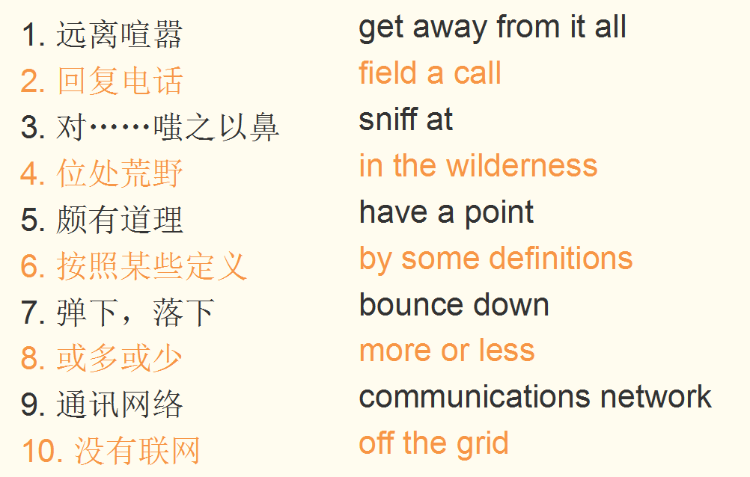

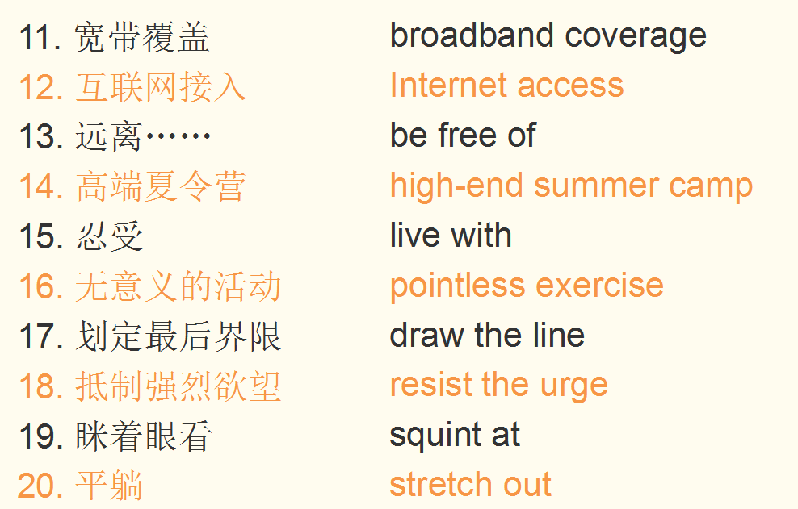

Unit 2

1. A soft murmur rippled across the room as students turned from side to side and whispered expressions of disbelief. (Para. 4)

教室里传开一片低语声，学生们交头接耳，对他的这番话难以置信。

1. They speak of courses one must “get out of the way”, and their advisors help them “check off” those requirements. (Para. 8)

学生提出想逃的课程，导师们则帮助他们满足修课要求。

1. They dismiss as meaningless anything about higher learning that doesn’t center on training someone to do a task that would make them money. (Para. 10)

他们认为，高等教育如果不以培训学生做事挣钱为核心，就是毫无意义的。

1. To grow on the ideas and creations of others, we must encounter them, and to do so, we must explore the great works of the mind found in the arts, sciences, mathematics, philosophies, and historical perspectives. (Para. 12)

要从他人的思想与创造中汲取营养，我们必须先接触到这些思想与创造，为此，我们必须广泛涉猎人文科学、数学、哲学和历史领域的伟大作品。

1. The world of ideas and scholarship becomes our oyster, and the possibilities become almost unlimited, at least as large as all of human endeavor and achievement throughout history. (Para. 12)

我们可在思想与学问的世界中大有所为，拥有近乎无限的可能性——至少与人类迄今为止所有的努力和成就一样宏大。

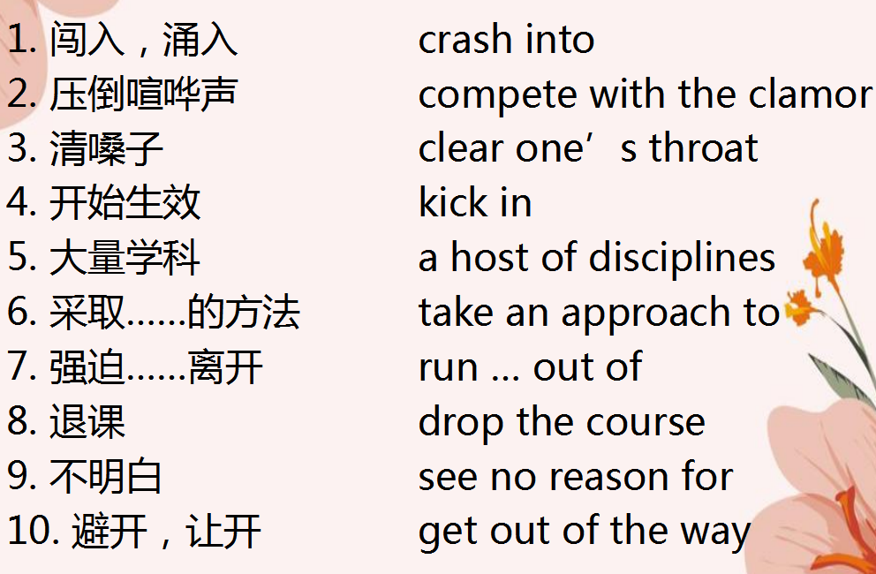

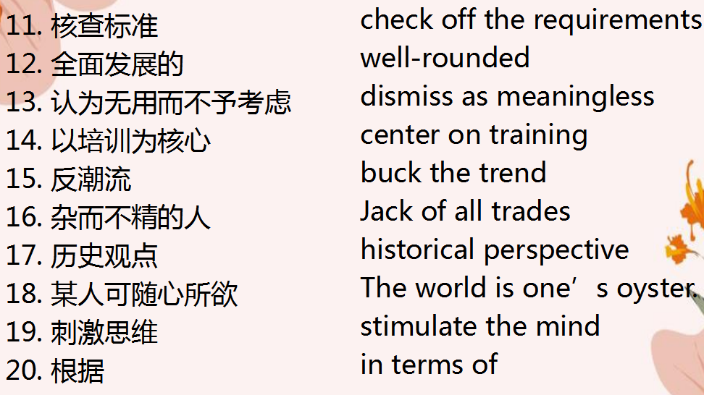

Unit 3

1. Not only did Jobs push the boundaries of what was considered possible, he radically changed our thinking about leadership and innovation (Para. 1).

乔布斯不仅拓宽了世人对于可为之事的想象，还彻底改变了我们对于领导力和创新精神的看法。

1. He maximized his own contribution, left us wondering what more might have followed, and inspired us to see the benefits of shifting our perspective and thinking in new ways (Para. 1).

他的个人贡献已达极限，我们几乎不知道在他之后还能再做些什么，这也激发我们明白了转变观念、创新思维带来的各种裨益。

1. He was a leader who struggled, like all of us, and whose life and leadership illustrated the developmental metamorphosis that is available to us all. (Para. 2)

作为领导者，他像所有普通人一样经历过种种挣扎。他的一生和领导能力表明，我们每个人都能在不断的改变和完善中成长。

1. Social mores reinforce the myth that leaders are supposed to be perfect and that struggle is a sign of weakness and a source of shame (Para. 3).

社会习俗更是强化了这种误解，人们认为领导者应该是完美的，挣扎是软弱的标志，是耻辱的根源。

1. This cultural programming, learned over many years, becomes ingrained, causing some leaders to lose their confidence and doubt their abilities, thinking something is wrong with them (Para. 3).

这些文化定势日积月累，已经变得根深蒂固，致使一些领导者丧失自信，怀疑自己的能力，觉得自身存在缺陷。

1. Yet they lack the insight to connect the dots between their own unenlightened behavior and the unfavorable outcomes they grumble about (Para. 6).

然而他们缺乏见识，无法洞察其愚昧无知的行为与不尽人意的结果之间的内在联系，却还对结果抱怨不休。

1. Choosing a new script frees them from the prison of stale thinking and unproductive behavior and leads to an understanding of how they can work with others to achieve some larger purpose or mission (Para. 7).

选择全新的剧本使他们获得解脱，不再受到陈腐思想和徒劳行为的束缚，并让他们认识到怎样与他人共事才能达成更大的目的，或完成更大的使命。

1. They derive happiness and fulfillment from not only their successes but also the intrinsic nature of the journey itself (Para. 8).

他们的幸福感和成就感不仅来自于自身的成功，更来自于这个过程的内在特征。

1. A new narrative surfaces, emphasizing the realization of human potential through the crucibles of adversity. (Para. 10)

一种新的观点浮出水面，强调通过逆境的历练实现人类潜力。

1. While traditional leadership narratives contemplate what and how, this struggle-centric narrative probes deeper, uncovering why. (Para. 11)

传统的领导观思考什么是领导力以及如何执行领导力，而这种以挣扎为中心的领导观更深入地进行探究，解密了为什么挣扎对于领导力至关重要。

1. A new perspective dawns when struggle is recognized as an intrinsic aspect of leadership and an opportunity for leaders to realize their full potential. (Para. 12)

当挣扎被视为领导力的本质层面，被视为领导者实现其全部潜力的机遇时，一种新的观点就应运而生。

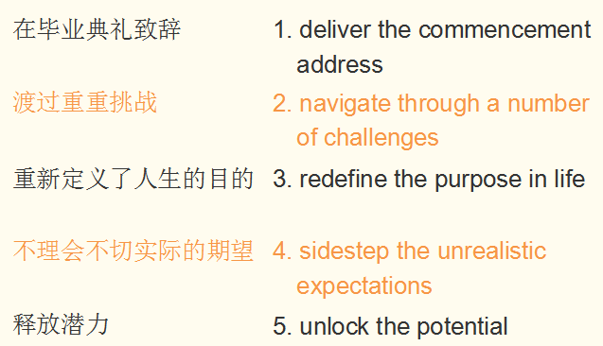

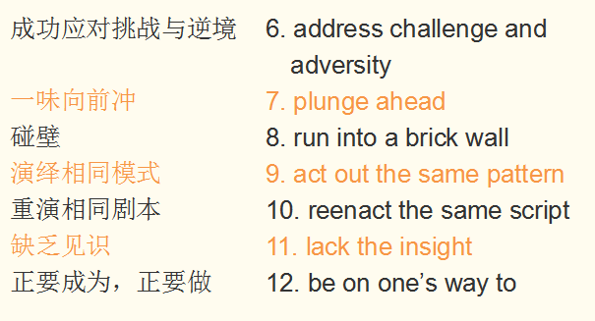

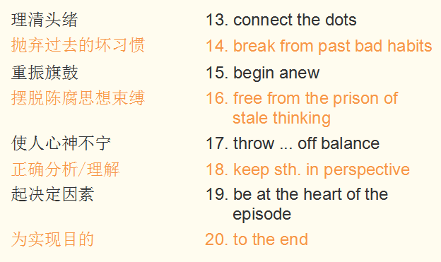

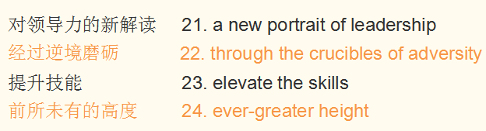

Unit 4

1. The painting resonates with art fans and the general public due in part to its vibrant palette and to the swirling motion that seems to draw viewers right into the center of the artist's fantastic vision. (Para. 1)

这幅画引起了艺术迷和普通公众的共鸣，部分原因是其鲜明色彩和旋涡流动似乎将观众吸引到了艺术家奇幻视觉的中心。

1. This tree serves to connect earth and sky and this could reflect the artist’s own thoughts about death — that death is the destination of life’s journey. (Para. 4)

这棵柏树连天接地，也许反映出梵高对于死亡的理解——死亡是生命之旅的终点。

1. His swirling brushstrokes give the impression that this painting is constantly moving and his palette is much more vibrant than that in earlier works. (Para. 7)

他涡旋式的笔触让人感觉他的画在不断地流动，画中的色彩比他在早先作品中所运用的更充满生机。

1. The artist’s attraction to the heavens and stars inspired some of his most famous paintings, including The Starry Night, Café Terrace at Night and Starry Night over the Rhone. (Para. 10)

梵高对天空与繁星的兴趣激发他创作出许多著名的画作，包括《星夜》、《夜间的露天咖啡座》与《罗纳河上的星夜》。

1. These internal elements ensure fluidity and such curved contours make The Starry Night’s composition distinct from the Impressionist technique of the 19th century. (Para. 13)

这些内部元素赋予画面一种流动感，这样的弯曲轮廓使《星夜》的构图与19世纪的印象派手法截然不同。

1. The dominance of blue is balanced by the orange of the night sky elements. (Para. 14)

夜空的橙色元素平衡了蓝色的大面积主控。

1. It seems that he is contrasting life and death with the luminous stars and a gloomy, peaceful village. (Para. 15)

梵高似乎通过描画明亮的星辰与幽暗静谧的村庄，让生与死形成鲜明对比。

1. In The Starry Night Van Gogh’s unique, thick brushstrokes are very much evident and there is a consistency to his technique that adds even more depth and texture to this work of art. (Para. 16)

在《星夜》中，梵高那独特的浓烈笔触十分明显。这一技法贯穿全画，使作品更具深度和质感。

1. Its bold brushwork and vivid colors contrasting with the dark tones of the night sky are believed to symbolize Van Gogh’s frame of mind and his search for hope during a time of great illness. (Para. 17)

他们认为其大胆的笔触、与夜空暗色调反差强烈的鲜明色彩，都象征着梵高重病中的内心世界和对希望的探求。

1. Disregarding the Impressionist principle of truth to nature and opting for a feeling of restlessness and vibrant color resulted in Van Gogh’s work becoming a benchmark for later Expressionist artwork. (Para. 17)

他弃用印象派忠于自然的写实原则，选择表达躁动不安的情感，并选用鲜明的色彩，这样的创作手法使其作品成为后来表现主义艺术作品的基准。

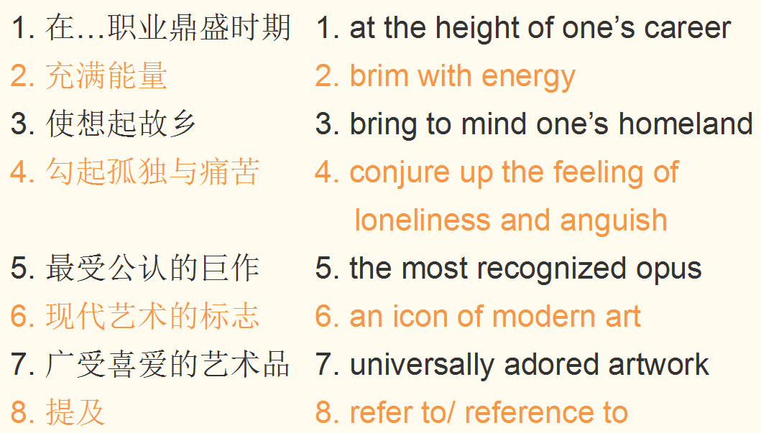

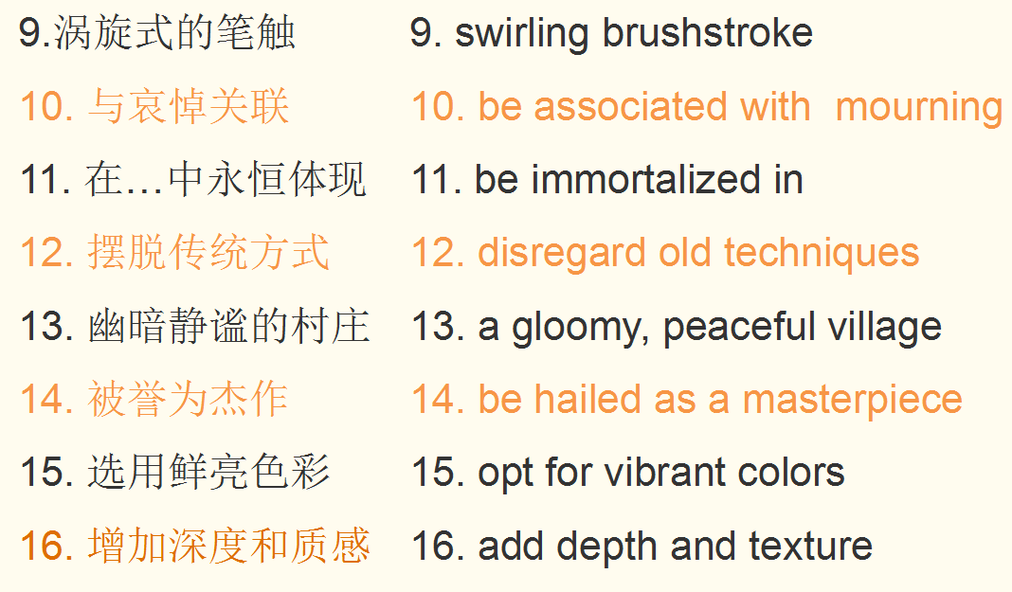

Unit 5

1. She was beautiful in a way that was decidedly unstenographic. (Para. 2)

她的美丽却绝不是草草几笔速记所能简单描述的。

1. Her dress was grey and plain, but it fitted her figure with fidelity and discretion. (Para. 2)

她的灰色裙子很素净，但相当合身，显身材又不失大方庄重。

1. On this morning she was softly and shyly radiant. (Para. 2)

这个上午，她身上焕发出一种温柔而羞怯的光彩。

1. The machine sitting at that desk was no longer a man; it was a busy New York broker, moved by buzzing wheels and uncoiling springs. (Para. 4)

坐在那办公桌前的可不再是个常人，而是一名忙碌的纽约股票交易“机器人”，轮子吱吱作响，弹簧绷得紧紧的。

1. His opened mail lay like a bank of stage snow on his crowded desk. (Para. 5)

拆开的信件躺在堆满东西的办公桌上，就像一片堆积起来的雪坡。

1. … not a single picture hat or piece of pineapple chewing gum has showed up yet. (Para. 8)

一个人都没来，既没有戴阔边帽的女士，也没有嚼菠萝口香糖的男人。

1. The desk telephone had a chronic attack of buzzing. (Para. 10)

桌上的电话像患了慢性病似地响个不停。

1. On the Exchange there were hurricanes and landslides and snowstorms and glaciers and volcanoes, and those elemental disturbances were reproduced in miniature in the broker’s offices. (Para. 11)

证券交易所里行情涨跌，像飓风，像山崩，像雪暴，像冰川和火山，而经纪人办公室里所发生的一切就是这些自然力量的缩影。

1. Maxwell shoved his chair against the wall and transacted business after the manner of a toe dancer. (Para. 11)

麦克斯韦尔把椅子猛推到墙边，像芭蕾舞者踮着脚尖跳舞般敏捷地处理业务。

1. Orders to buy and sell were coming and going as swift as the flight of swallows. (Para. 19)

下单买进卖出，来去疾如飞燕。

1. … the man was working like some high-geared, delicate, strong machine — strung to full tension, going at full speed, accurate, never hesitating, with the proper word and decision and act ready and prompt as clockwork. (Para. 19)

他就像一台高速运转、精密而强大的机器那样工作着——精神绷紧到最大限度，开足马力，准确精密，从不犹豫，言语、决策和行动都像机械装置那般，正确无误，准备充分，反应迅速。

1. … here was a world of finance, and there was no room in it for the human world or the world of nature. (Para. 19)

这是一个只有金融业务的世界，容不下丝毫人情世故、自然山水。

1. … a wandering — perhaps a lost — odor …(Para. 21)

窗口飘进了一缕气息——或许是一种久违的气息——一股优雅的丁香花香气

1. The world of finance shrank suddenly to a particle. (Para. 22)

金融世界转瞬间缩成了一粒尘埃。

